**Experiment 14**

Name: Aayush kumar

R171218002

**Aim:** To build custom Docker image of webserver using Dockerfile

1) Create a html file to deploy on server.

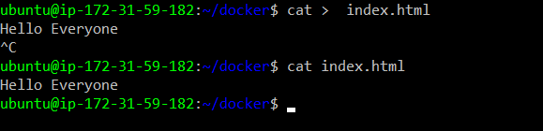

2) Create Dockerfile as shown below.

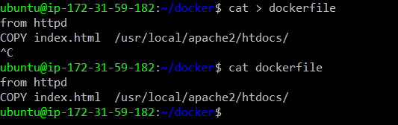

3) Now use command docker build –t <image-name> <path-of-Dockerfile> to build custom image.

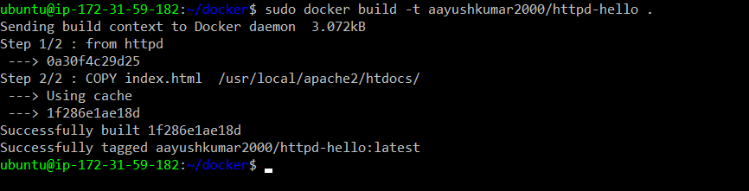

1. Use command docker push to push your image on to DockerHub.

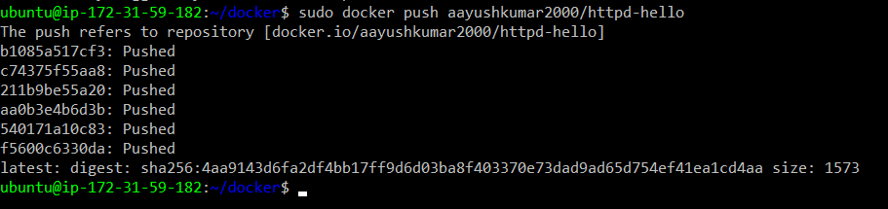

5)Now use command docker run –d –p 8888:80 to run a container of your custom image and expose this container to outside world.



